**Que sobro donte application**

This app lets you search for recipes with the ingredients you have left in your fridge.

**Details**

1. Search for recipes, select recipe from the results, add notes, add to my recipes.
2. Wireframes for each view.

**Home**

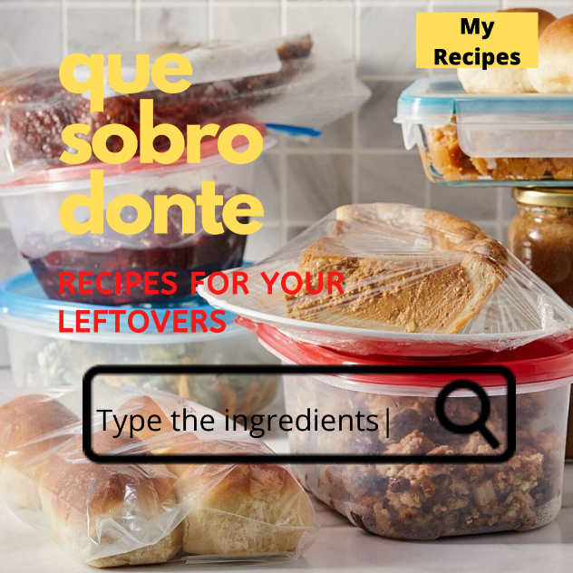

**Results**

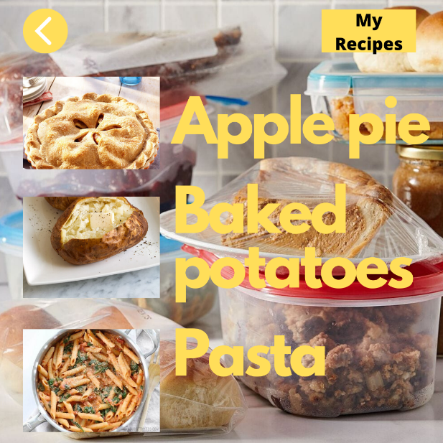

**Recipe**

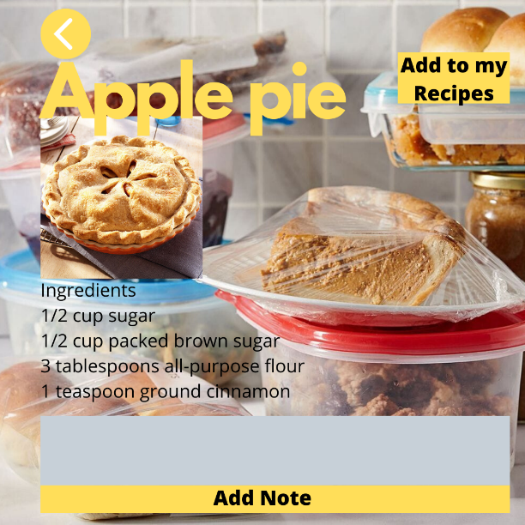

**My Recipes**

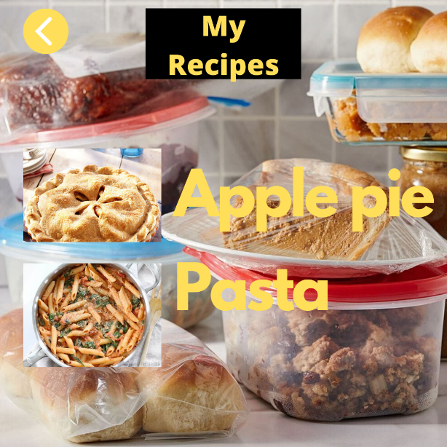

1. UI actions
   1. Search recipes with ingredients
   2. Select recipe from results
   3. Save recipe
   4. See saved recipe
2. Data sources: localStorage and recipe API
   1. Recipe API: <https://spoonacular.com/food-api>
3. Initial Module list: QueSobro.js, localStorage, utilities.js
4. Colors/Typography/specific Element styling:   
   Black, Yellow and Red  
   Century Gothic, Arial